ADVENTURE WORKS BI CASE STUDY

AIM:
Problem Statement: You are a BI Analyst in Green Eco Corp. The management has asked to analyze their data and create some attractive yet informative visualizations. (Refer the dataset: Adventure Works.csv)

Q1: Create a Bar in Bar chart on Sales and Profit by Country to compare these Measure against one another.
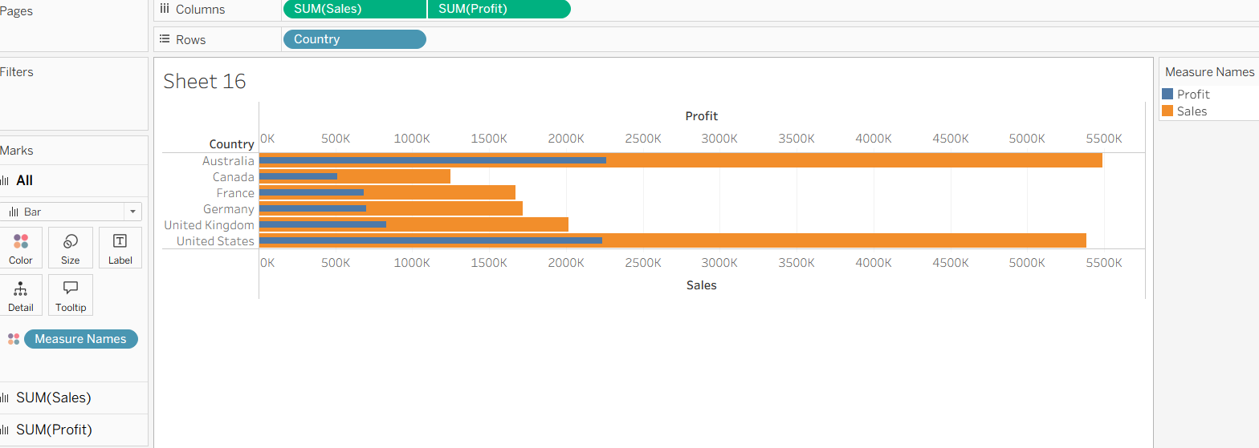

Q2: Create a Gantt chart that displays difference in Order quantity of each Category at Country Level. The duration of the chart should be on Week Continuous level.
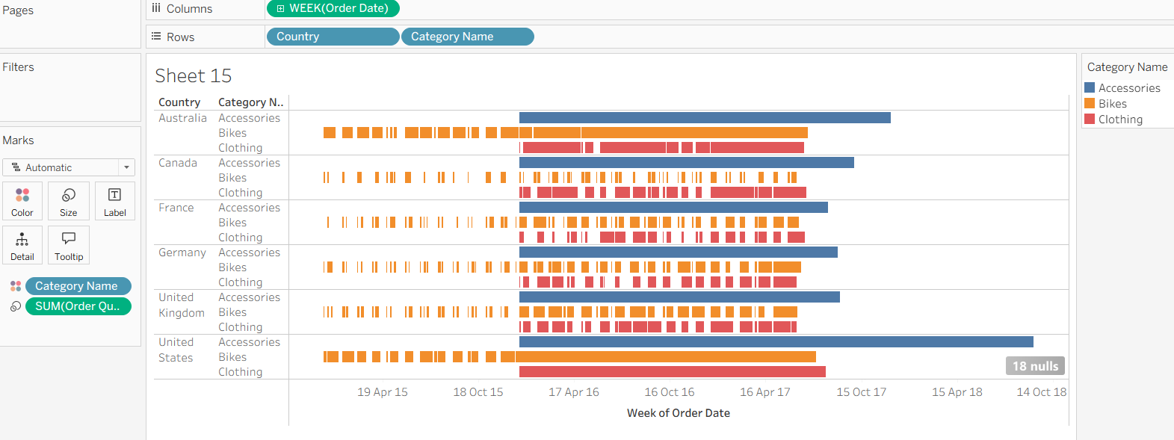

Q3: Create a Step and Jump line chart, displaying Cumulative Sum of Sales at Continuous Quarter level.
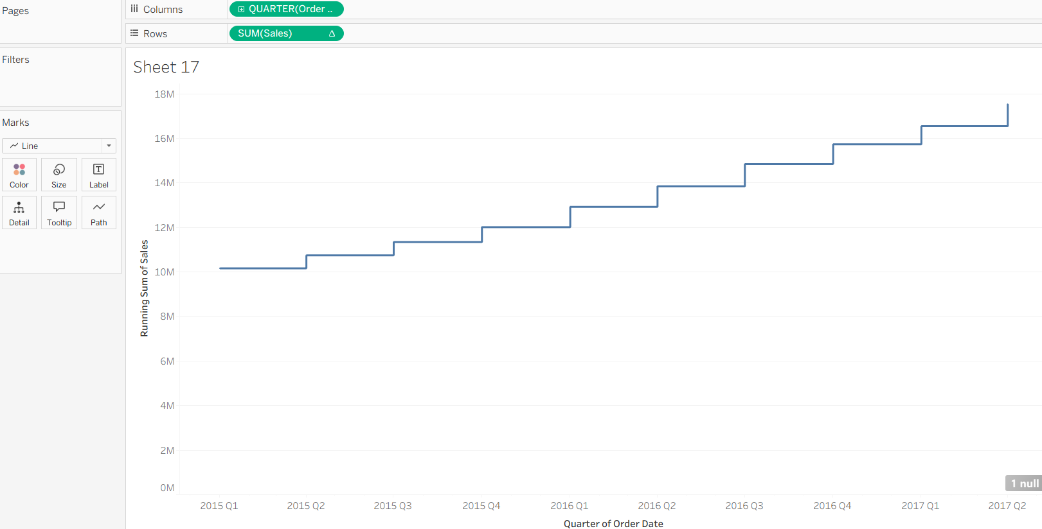
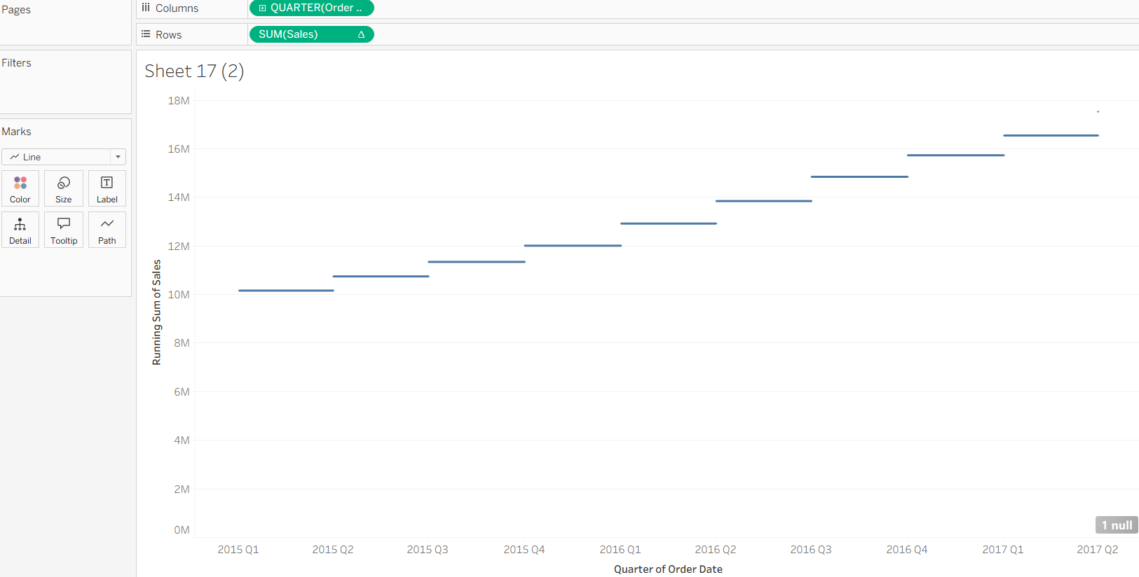

Q4: Create a Funnel chart by Profit and Region and find the trend.

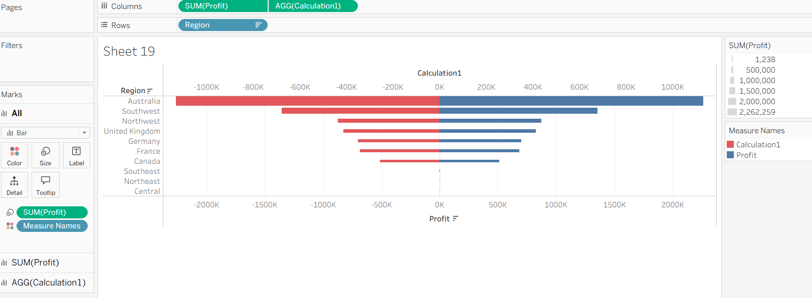

Q5: Create an Area Funnel chart by Order Quantity at Discrete Quarter level also reverse the chart in order to give it a proper funnel shape.
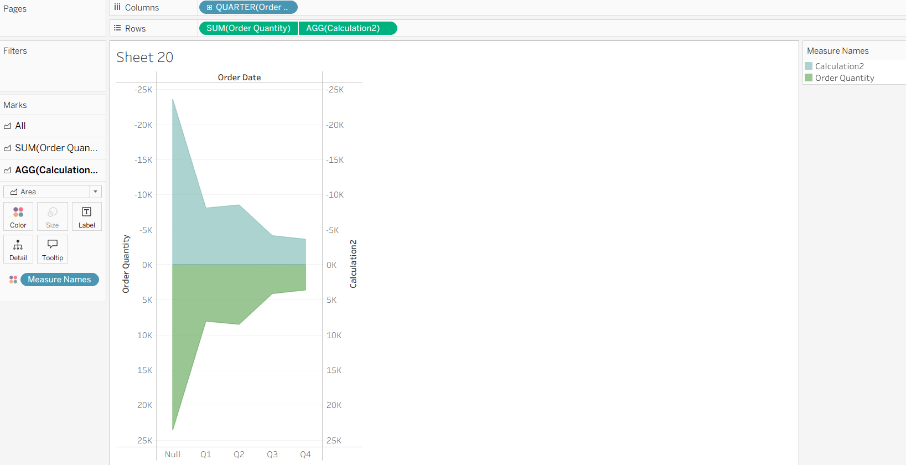

Q6: Create two Word Clouds in two separate sheets. The first chart should be on Sub-category where the Size and Color represent Profit and the second chart should be on Country where Size represents the Sales and Color represents the Country.



